BREAST CANCER PREDICTION
Using Logistic Regression (Day 8 Assignment)
Name: Manish Giri | Reg. No: 137256 | Email: manishgiri8101@gmail.com | [LinkedIn]

1. Introduction
This report presents a complete implementation of Logistic Regression for binary classification of breast tumor data from the Wisconsin Diagnostic Breast Cancer (WDBC) dataset. The objective is to predict whether a tumor is Malignant (M) or Benign (B) based on 30 numerical features derived from digitized images of fine needle aspirate (FNA) of breast masses.
- Dataset: Wisconsin Diagnostic Breast Cancer (WDBC)
- Algorithm: Logistic Regression (sklearn)
- Task Type: Binary Classification (Malignant vs. Benign)
- Language/Tools: Python, Scikit-learn, Seaborn, Matplotlib, Pandas

2. Dataset Overview
The dataset contains 569 samples with 31 features (30 numeric + 1 target column). Each sample is a digitized image measurement of a breast mass. The Unnamed: 32 column (all NaN) was removed during preprocessing.

2.1 Dataset Shape and Structure
df.shape => (569, 31) # 569 rows, 31 columns (after removing Unnamed:32)

Columns: diagnosis, radius_mean, texture_mean, perimeter_mean, area_mean,
smoothness_mean, compactness_mean, concavity_mean, concave points_mean,
symmetry_mean, fractal_dimension_mean, + 20 more SE and worst features

2.2 Class Distribution
The dataset has an imbalanced class distribution with more Benign cases:

Number of cells labeled Benign : 357 (62.74%)
Number of cells labeled Malignant : 212 (37.26%)

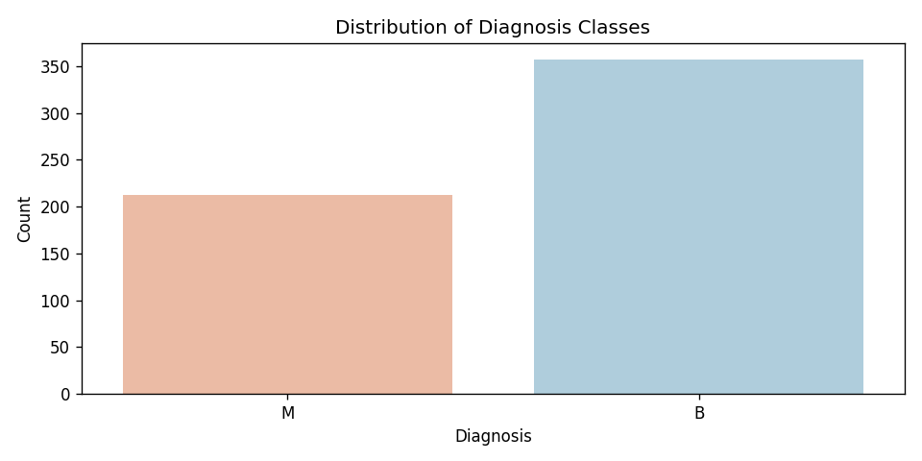
Figure 1: Distribution of Benign vs. Malignant tumor diagnoses

3. Exploratory Data Analysis (EDA)
EDA was performed to understand feature distributions, relationships between features, and correlations. Two primary visualizations were generated.

3.1 Pairplot of Mean Features
A scatter plot matrix (pairplot) was generated for the 10 mean measurement features colored by diagnosis class. This reveals that features like radius_mean, perimeter_mean, area_mean, and concavity_mean show strong class separation between Benign and Malignant tumors.

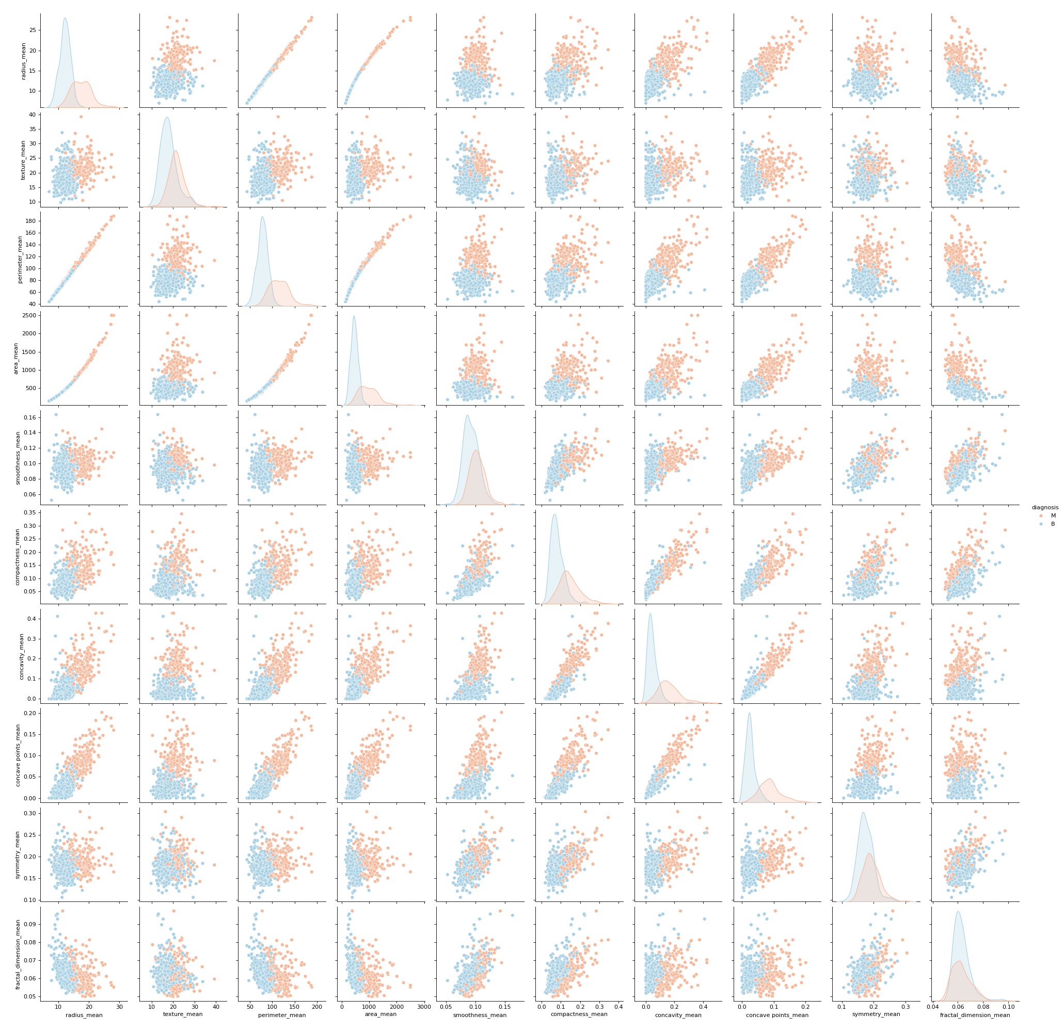
Figure 2: Pairplot of mean features colored by diagnosis (Red = Malignant, Blue = Benign)

3.2 Correlation Heatmap
A full correlation heatmap was generated across all 30 numeric features. Key observations:
- radius_mean, perimeter_mean, and area_mean are highly correlated (>0.99).
- concavity_mean and concave points_mean show strong correlation (>0.90).
- Many worst features are correlated with their respective mean features.

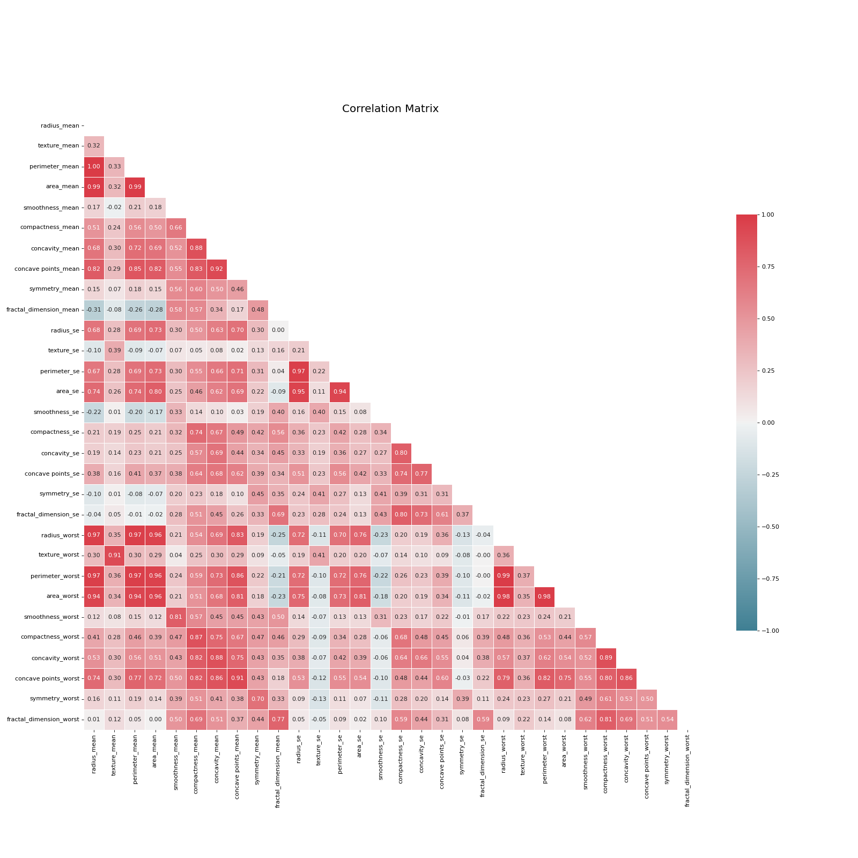
Figure 3: Correlation heatmap of all 30 numeric features
4. Data Preprocessing
The following preprocessing steps were applied before model training:

4.1 Removing Irrelevant Column
# Remove the Unnamed: 32 column (all NaN values)
df = df.drop('Unnamed: 32', axis=1)

4.2 Encoding Target Variable
# Encode diagnosis: Benign=0, Malignant=1
df['diagnosis'] = df['diagnosis'].map({'B': 0, 'M': 1})

4.3 Train-Test Split
X = df.drop('diagnosis', axis=1) # 30 features
y = df['diagnosis'] # target

X_train, X_test, y_train, y_test = train_test_split(
X, y, test_size=0.3, random_state=40
)

# Training set: 398 samples
# Testing set: 171 samples

4.4 Feature Scaling
# StandardScaler normalizes features to mean=0, std=1
scaler = StandardScaler()
X_train = scaler.fit_transform(X_train)
X_test = scaler.transform(X_test) # fit only on train

5. Model — Logistic Regression
Logistic Regression was selected for this binary classification task. It models the probability of a sample belonging to the Malignant class using a sigmoid function applied to a linear combination of features.
model = LogisticRegression(max_iter=10000)
model.fit(X_train, y_train)

y_pred = model.predict(X_test)
y_prob = model.predict_proba(X_test)[:, 1] # probability for ROC-AUC

max_iter=10000 was set to ensure convergence of the solver on the 30-dimensional scaled feature space.

6. Model Evaluation & Results
The model was evaluated on the held-out test set (171 samples) using multiple classification metrics.

6.1 Performance Metrics

Metric | Score | Interpretation
Accuracy | 0.977 (97.7%) | 97.7% of all predictions are correct
Precision | 0.964 (96.4%) | 96.4% of predicted malignant tumors are truly malignant
Recall | 0.964 (96.4%) | 96.4% of actual malignant tumors are detected
F1 Score | 0.964 (96.4%) | Strong balance between precision and recall
ROC-AUC | 0.992 (99.2%) | Near-perfect class separation ability

6.2 Classification Report
Class | Precision | Recall | F1-Score | Support
0 (Benign) | 0.98 | 0.98 | 0.98 | 115
1 (Malignant) | 0.96 | 0.96 | 0.96 | 56
Accuracy |  |  | 0.98 | 171
Macro Avg | 0.97 | 0.97 | 0.97 | 171
Weighted Avg | 0.98 | 0.98 | 0.98 | 171

6.3 Confusion Matrix
The confusion matrix shows the count of True Positives, True Negatives, False Positives, and False Negatives:

Confusion Matrix:
Predicted Benign Predicted Malignant
Actual Benign 113 2
Actual Malignant 2 54

True Negatives (TN): 113 | False Positives (FP): 2
False Negatives (FN): 2 | True Positives (TP): 54

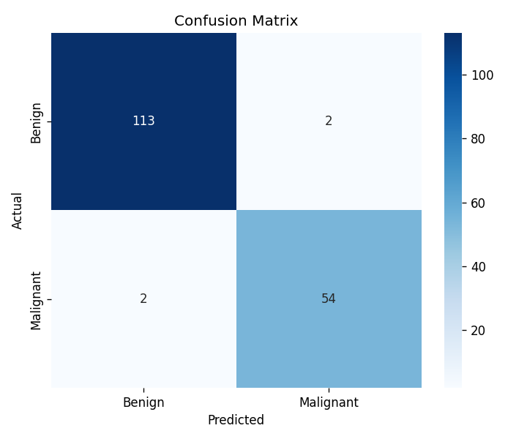
Figure 4: Confusion Matrix — Predicted vs. Actual class labels

6.4 ROC Curve
The Receiver Operating Characteristic (ROC) curve plots the True Positive Rate against the False Positive Rate at different classification thresholds. An AUC of 0.9920 confirms near-perfect discrimination ability.
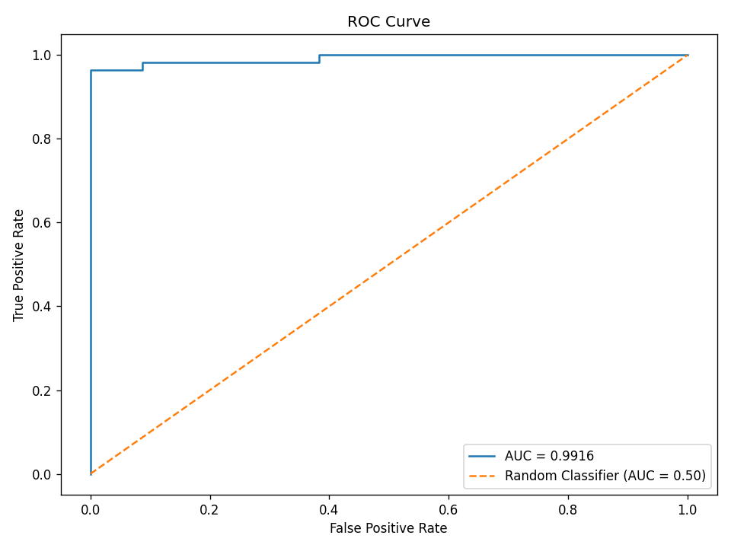
Figure 5: ROC Curve with AUC = 0.9920
7. Conclusion
The Logistic Regression model trained on the Wisconsin Diagnostic Breast Cancer dataset achieved exceptional performance across all evaluation metrics. The key findings are summarized below:
- Accuracy (97.7%): The model correctly classified 168 out of 171 test samples.
- Precision (96.4%): Very few false positive predictions — only 2 Benign tumors were misclassified as Malignant.
- Recall (96.4%): The model detected 96.4% of all actual Malignant tumors, missing only 2.
- F1 Score (96.4%): Strong and balanced trade-off between precision and recall.
- ROC-AUC (99.2%): Near-perfect class separation, confirming the model's strong discriminative power.

Overall, Logistic Regression proved to be a highly effective algorithm for this medical classification task. With proper feature scaling and a 70/30 train-test split, the model achieved results comparable to more complex algorithms. These results suggest that the 30 features from FNA imaging provide highly informative signals for tumor diagnosis.

